**Data Evaluation**

Confusion matrix

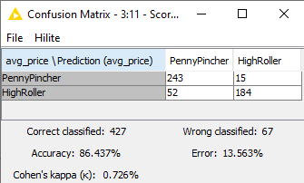

The accuracy of the model is 86.43%

When the buyer type is PennyPincher, the model classified correctly 243 times and incorrectly 15 times. When the byer type is HighRoller, the model classified correctly 192 times and incorrectly 52 times.